**Machine Learning and Deep Learning Summer Internship**

**Assignment – 7**

**Name – Siddhi Bansal**

**ID – SIRSS1124**

**Q.1 Create a file via touch and update that file and also verify the timestamp and output will be redirected to another file.**

**Step 1:**  Create a new directory by "mkdir"cmd .

**Step 2:** Move to that directory using “cd” cmd .

**Step 3:**  Further use “touch” command to create a new file. Always keep in mind that touch cmd is used to update the timestamp of file and if file is not present in directory than only it will create it .

Step 4: After that check whether the file is created or not using "ls".

**Step 5:** Now check the timestamp of the fileusing "ls -la" cmd.

**Step 6:**For writing something in file use vim editor. To enter the editor use "vim filename" command.

**Step 7:** Go to insert mode by pressing “i” key to write something.

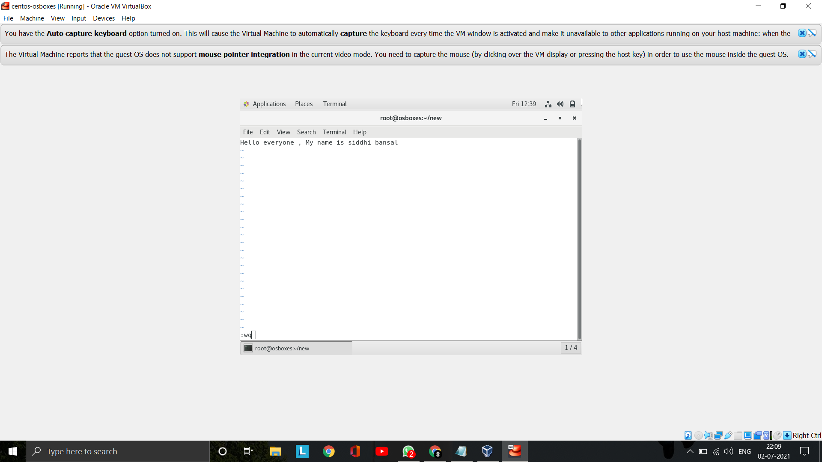

**Step 8:** After writing press "ESC" key on keyboard and type ":wq" and hit "Enter" key for quitting the file and save the file.

**Step 9:** For displaying the file content use "cat" cmd.

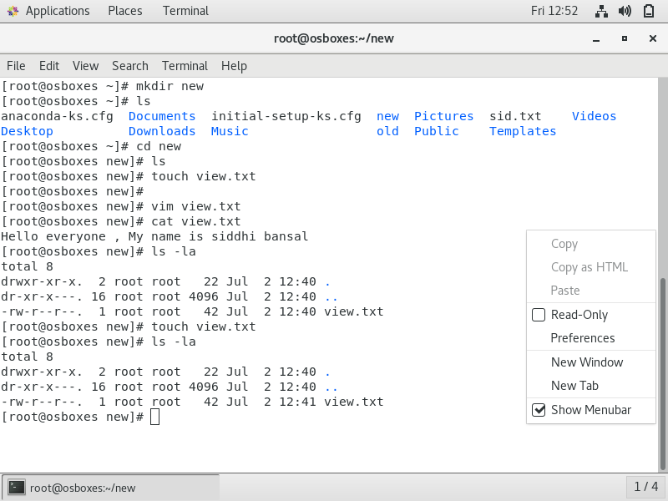

**Q.2 Add some of the data as per your choice and append that data via echo command in the same file.**

To write something in file without opening it and append it with the existing data, we use "echo" command.

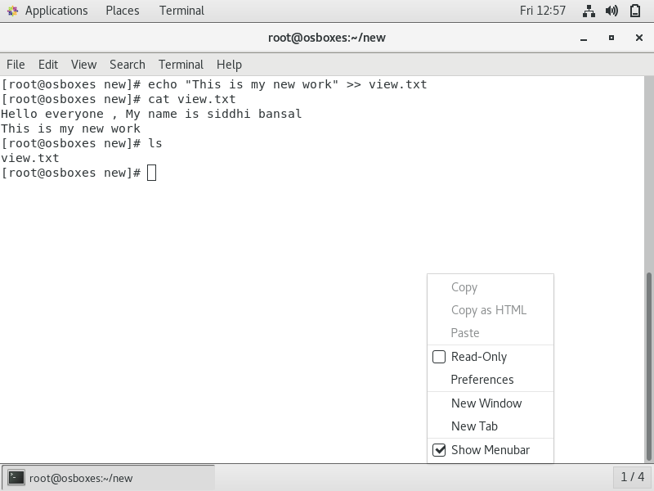

**Q.3 Install httpd and set up your own web server.**

**Step 1:** Install httpd by "yum install httpd -y > /dev/null" command.

**Step 2:**For starting the service of httpd use "systemctl start httpd" command.

**Step 3:**For enabling httpd (by default it is disabled) use "systemctl enable httpd" command.

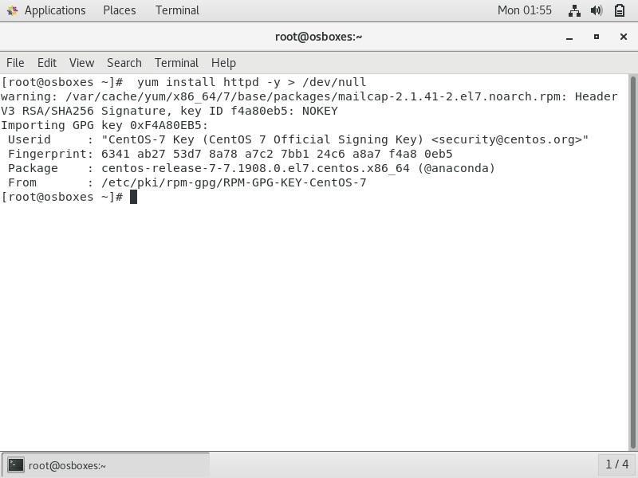

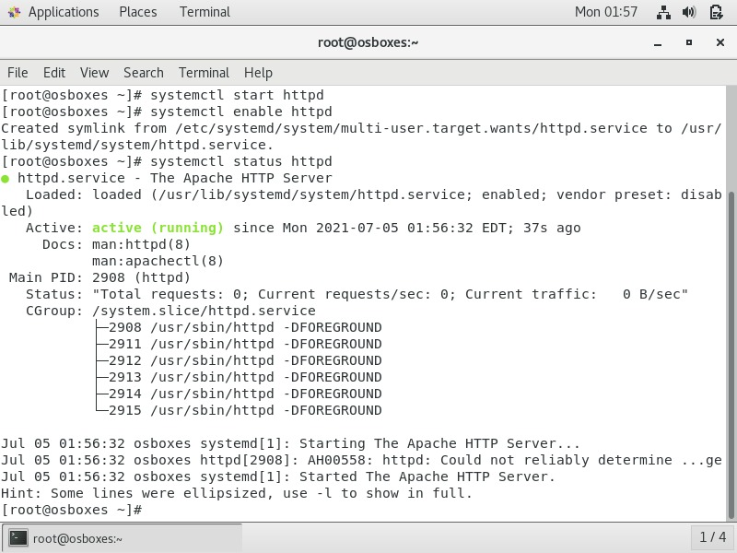

**Step 4:**Check the status of httpd by "systemctl status httpd" cmd .

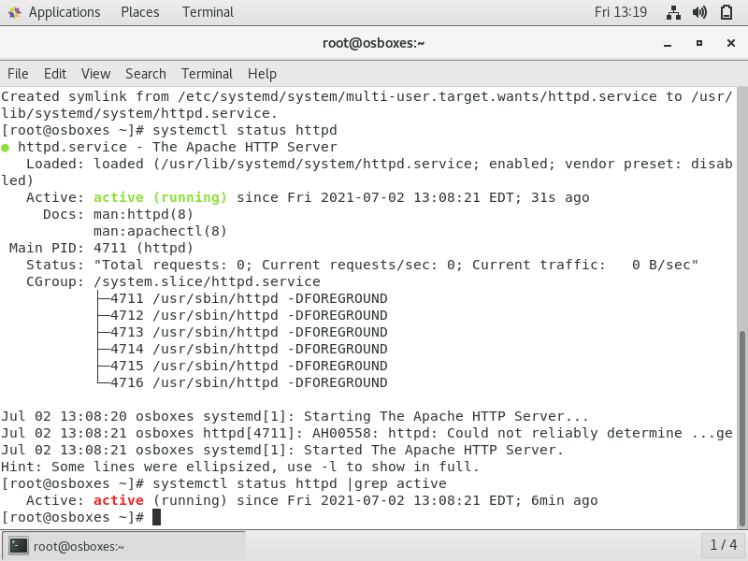

**Q.4 Copy some files from one Linux host to another Linux host via SCP.**

**Step 1:** Firstly open both the hosts and rename as "host1" and "host2" using "hostnamectl set-hostname host1" and "hostnamectl set-hostname host2" cmd. Next use "exec bash" cmd to execute name change operation.

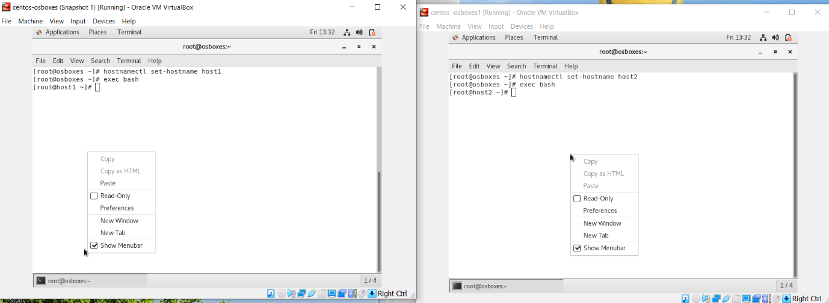

**Step 2:**Check ip address of both the hosts by "ifconfig enp0s3 | grep inet" cmd.

**Step 3:** Then create a new file in host1 using "vim" cmd and then write something in it.

**Step 4:**Transfer the file from host1 to host2 by using **SCP Service,** for this use the cmd "scp filename root@(host2’s IP address):/tmp". The password of host2 will be asked from you at this time.

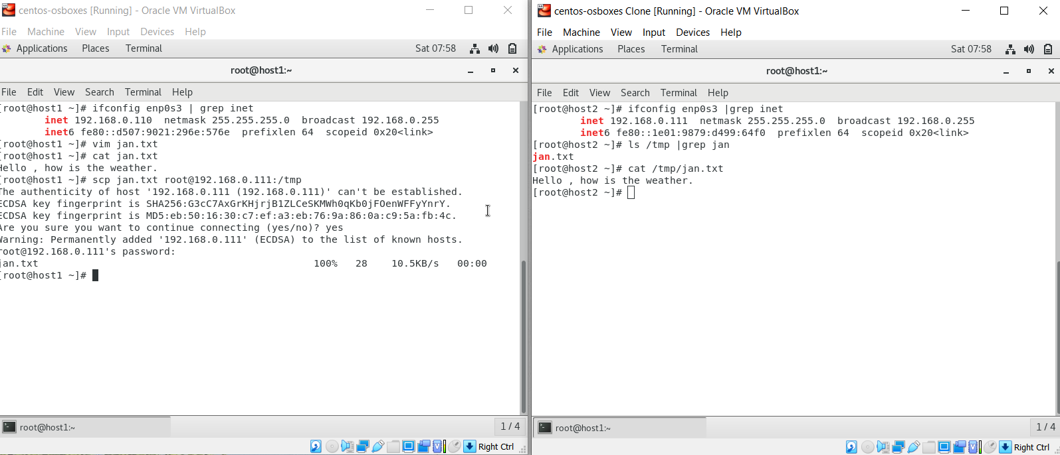

**Q.5 Create another VM and setup password less authentication.**

Another VM is setup by cloning the current VM.

**Step 1:**Go to Oracle VM VirtualBox and right click on the current CentOS machine and select ‘Clone’ option.

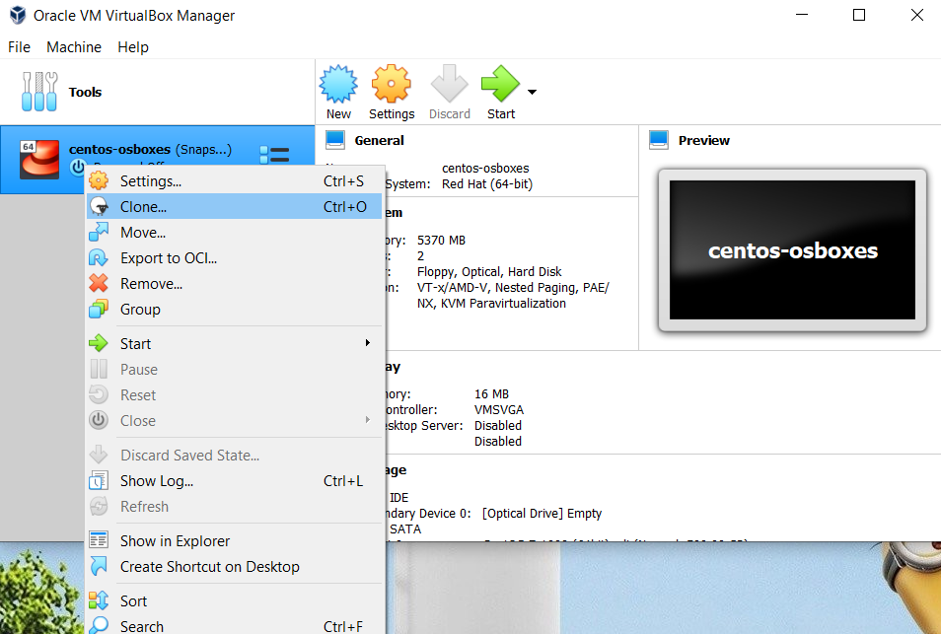

**Step 2:**Keep all the default settings and then click ‘Next’ button.

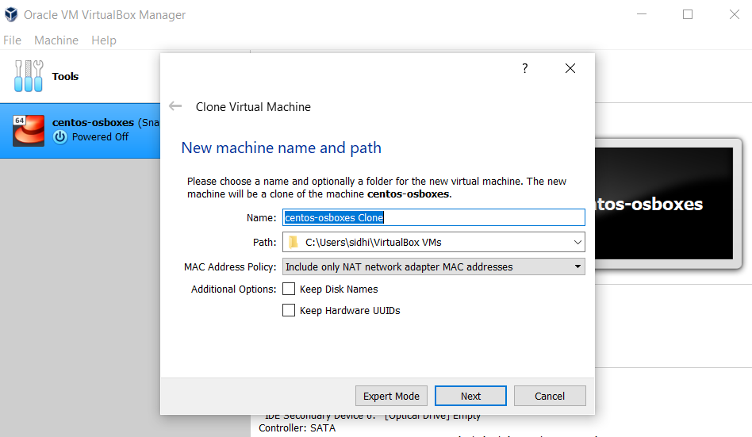

**Step 3:**Next select ‘Full Clone’ option in next window.

**Step 4:**At last click next. System will create another CentOS machine in VirtualBox Environment.

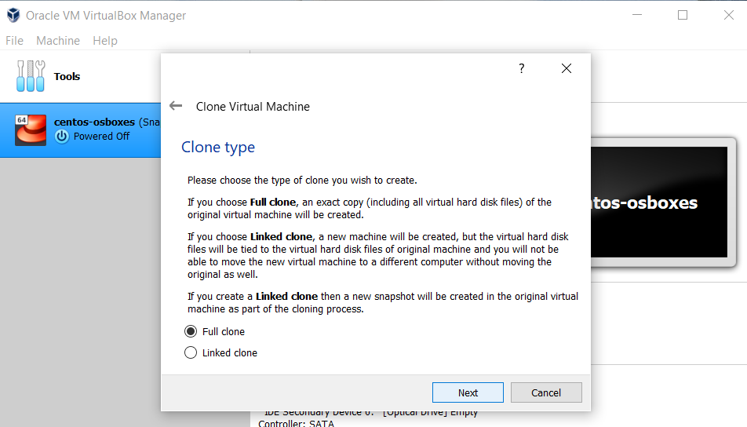

* **Setup PASSWORD Of LESS AUTHENTICATION .**

**Step 1:**First generate the key using "**ssh-keygen"** cmd in host 1 and enter the required authentication credentials.

**Step 2:**Next , copy this key by using the command "ssh-copy-id root@(host2’s IP address)". Then host2 will verify the key and when the key is matched, it means we can easily login now. After this we do not need to enter the password while accessing host2 in this environment.

This is the way to access a different host using less authentication password setup.

